1. Create **Empty GameObject** and call it **Player Rig**
2. Copy the Main Cameras coordinates over to the Player Rig
3. Move the **Main Camera** and the **Player ship** under the **Player Rig**
4. Click on **Window> Sequencing > Timeline**

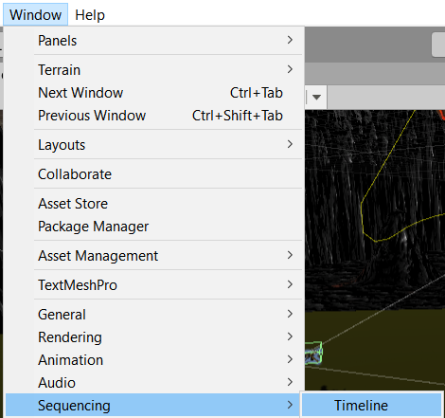

1. Lets move Timeline down next to your Console
2. Click on **Window > Animation > Animation** and place it next to Timeline
3. Create **Empty Gameobject** and name it **Master Timeline** and reset its position

So this point you might be saying what is actually timeline. Timeline is a tool that allows us to animate things within our game. For example, cut scenes or cinematic sequences. We can animate enemies moving within our world. We can animate things to fall or move in our world. As we're moving around in our world, we can trigger timeline events to happen.

1. Click on **Master Timeline** then in your **Timeline** window click the **Create** button
2. Create new folder in call it **Timeline**
3. Make the name is **Master Timeline** with only ONE Timeline and click **Save**
4. Set timeline to Seconds by click on the gear on the right

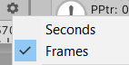

1. Click on the **lock** Icon above that gear icon too.
2. Click on the **Plus > Animation Track**

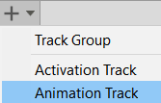

1. Drag **Player Rig** to the new Animation Track field then Select **Create Animator on Player Rig**

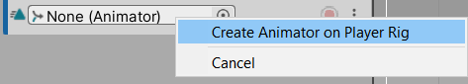

1. Click on the **Record** button



1. Grab your **Player Rig** and jiggle it up and down to create a **Key Frame** denoted by the grey diamond. That's saying we are recognizing this particular spot in space.
2. Move **Slider** to **1 second** mark and lift your **Player Rig** a bit to denote liftoff. Now it doesn’t matter if you don’t get it right initially. The only thing it records is its final spot.
3. Move timeline to **3 seconds** move your scene to where you want your ship to move to. Select **Player Rig** then go to **GameObject> Align with view**. This should have moved everything to where you were looking at and create a Key Frame.
4. Now if you move your slider you should be able to see your Player Ships current path
5. Click on Edit > Preferences > Colors and look for Grid. Change this color to something that pops.

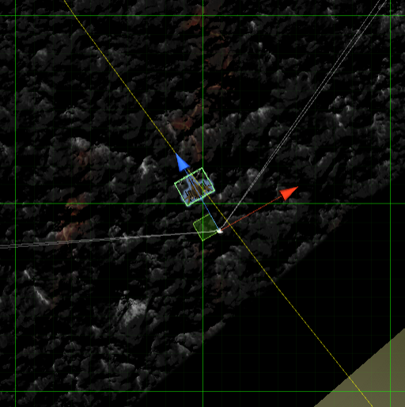

1. Now it takes about 2 seconds to cross a square.
2. Move the slider to 5 seconds and move your Player Rig a grid.
3. Turn **OFF record**. Move the **Slider to 0** and **press Play**.

If needed remove the Waypoint script from the Main Camera and delete the Circuit GameObject